(Approx. 733 words)

Create and Save a Custom Footer in Word
By Nancy DeMarte, 1st VP, Sarasota PCUG, Florida
January 2014 Issue, PC Monitor
www.spcug.org
ndemarte (at) Verizon.net

As you build up a library of documents you have written, it helps to have a system to have some sort of ID on each document to help you remember where it is stored. A good place to record this information on a document is in a footer along the bottom of each page. In Word 2007 and later, you can easily create a custom footer which includes the information you want and save it in a handy spot called the Building Block gallery for insertion into any document. Here is how it’s done.

For illustration, I chose to create a footer which includes the date the document was created and the file name, including the path. The path shows the location of a file by listing all the folders and subfolders which need to be opened to find it, beginning with the hard drive (c:).

First I opened a document I had saved that had no footer. I clicked the Insert tab, and then Footer. From the gallery of footers, I clicked the footer labeled, “Blank (Three Column)” even though I was adding only two pieces of information. I then scrolled down to find my footer at the bottom of the page with my cursor flashing inside the footer area.
To customize the footer, first I highlighted the left placeholder and pressed Delete to remove it. Leaving my cursor in that spot, I clicked the Insert tab in the ribbon, then Quick Parts – Field. I scrolled down the list and clicked “FileName.” I chose lower case for its format, and checked the box which said, “Add path to filename.” When I clicked OK, the entire path appeared in the footer.

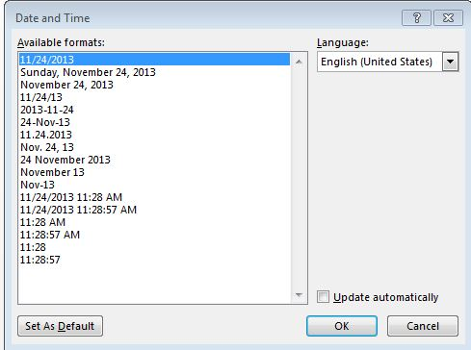
Then I highlighted the center and right placeholders and deleted them. (I knew I would not be using the center placeholder with this footer, but a page number fits very well in that center spot.) My cursor was then flashing in the spot where the right placeholder had been. To add the date, I clicked the Insert tab again, then Date & Time, which opened the Date and Time dialog box. I opted for the default date format (first one on the list). Now I had a choice: Do I want the date to remain static to remind me when I composed this document, or do I want it to update to the present date each time I open it. I decided not to have the date update automatically. So I clicked to remove the checkmark from the option, “Update automatically.” I knew I could always update the date manually by clicking it in the footer and selecting Update.

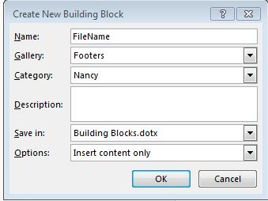
My last step was to save this footer so I could reuse it on other documents. I double clicked in the footer area and highlighted the entire footer line. I clicked the Insert tab – Quick Parts – Save Selection to Quick Parts Gallery. The Create New Building Block dialog box opened with several choices to make. I named my new footer, “FileName” and put in the Footers gallery. Then I clicked the arrow next to Category, chose Create New Category and typed my first name. This way it would be easy to find my custom footer by looking in the Building Block organizer. I left the last two lines as they were, Building Blocks.dotx and Insert content only.

To make sure I had succeeded, I saved my document and closed it. When asked if I wanted to save a new building block, I clicked yes. From now on, if I want to add this footer to a document, all I do is open the document, click Insert – Footers and choose it from the Footer gallery. If I add it to an unsaved document, of course, the filename will be Document 1 with no path. I can always delete it from the Building Block organizer, which will make is disappear from the Footer gallery, as well.

I have created several customized quick parts, depending on my task. The one I use the most has my name on the left, page number in the center, and date on the right. Creating footers, headers or any other groups of text that you reuse often can be a real time-saver. They are worth exploring.

